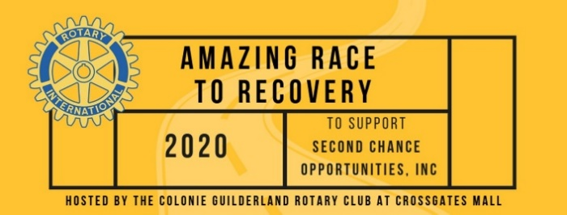
Contact: Erin Moore
Assistant Marketing Director
Crossgates Management Office
ErinMoore@pyramidmg.com
(518) 869-3522 ext. 5
FOR IMMEDIATE RELEASE
January 6, 2020

THE AMAZING RACE “TO RECOVERY”
AT CROSSGATES JANUARY 25, 2020
Create awareness on the opioid epidemic and raise funds for Second Chance Opportunities
A Community Recovery Center in Albany – all through a fun, family-friendly event

Drug overdoses killed 72,306 Americans in 2017; 49,068 from opioids! The Capital Region has not been spared by the crisis. The Colonie-Guilderland Rotary Club needs your help making recovery from addiction sustainable in our home towns! They are excited to announce that they have collaborated with Crossgates – the site of The Amazing Race To Recovery, a fun, family-friendly event where teams complete competitive challenges in stores (with no running allowed).
The event will be held at Crossgates on Saturday, January 25, 2020, from 8:00 a.m. – 2:00 p.m. Participating stores include: Pro Image Sports, UNO Pizzeria & Grill, LEGO, Apex Entertainment, Dave & Buster’s, Auntie Anne’s, Best Buy, Dick’s Sporting Goods, The Art of Shaving, Skyloft, 5 Wits, ThinkGeek, Yogibo, Starbucks, 110 Grill, Trollbeads, and Short & Stout.
Samples of the challenges are: pizza box building at UNO’s, LEGO Pictionary, laser tag at APEX, pretzel making at Auntie Anne’s, arcade games at Dave & Buster’s, and trivia at ThinkGeek!
A community forum to raise awareness and inform people of effective ways to help fight this crisis will precede the “Race.” Funds raised will be used to support programs at the Community Recovery Center in Albany.
The event is open to the public. Teams of two to five people may participate. Cost is $20 per person, $25 after 1-23-2020. Teams can register for the event at www.amazingracetorecovery.org. Sponsorships are available at levels from $150-$5000. Companies or organizations wishing to support the event can sign up as sponsors via the website or have their employees from teams and participate in the event.
Second Chance Opportunities, Inc., is creating a safe, centralized center where people in recovery, their families and loved ones can go to get support necessary to lead healthy lives in recovery and cope with the challenges of addiction. People in recovery can put their lives back together by gaining employment, housing, life skills, and being a part of a recovery community. They’ll learn to have fun and enjoy themselves without the use of substances, which greatly reduces the risk of relapse. Opportunities such as Sober Sunday Football, St. Patrick's Day Parties, Pot Lucks, Game Nights, Trivia Nights, Paint and Chip and other special holiday events are some great examples of what Second Chance Opportunities does to build relationships with and provide support from, families, recovery counselors and other individuals in recovery.
"Over the years we have learned one of the keys to a life of sobriety is proper support during the transition from treatment to Recovery, we refer to this as the "gap" or the "bridge." This period of time is vital to an individual’s Recovery. It's when we arm ourselves with the appropriate tools and methods to sustain recovery. Here at Second Chance Opportunities, we work to build those skills, to fit each individual’s needs. The results are powerful, and they are what make the Recovery movement here in the capital region possible." - Kellie Roe, Executive Director.
The major sponsors include: Crossgates, Skyloft, CDPHP, BlueShield of Northeastern New York, Alliance for Better Health, Amsure Insurance, Adirondack Electronics, Faddegon’s Nursery, Datto Inc. & Grassland Equipment.
Visit www.amazingracetorecovery.org for more information, to register your team, sponsor the event, or even to sponsor someone in recovery so they can participate.
# # #

ABOUT CROSSGATES
Crossgates is the Capital Region’s premier shopping, dining and entertainment destination offering an impressive selection of national brands and the newest retail concepts. The center is anchored by Lord & Taylor, Macy’s, JCPenney, Dick’s Sporting Goods, and Best Buy, while offering more than 180 retail shops, including Apple. Crossgates offers 10 entertainment venues and over 20 on-site eateries, such as Dave & Buster’s, Apex Entertainment, Skyloft Live Music, The Standard, and Regal Cinemas with IMAX. Combined with a dual-branded 192-room Homewood Suites and Tru by Hilton, Crossgates is your destination to EAT. SHOP. PLAY. STAY. Additional information regarding Crossgates can be found at shopcrossgates.com, Facebook, Instagram, and Twitter.

ABOUT PYRAMID MANAGEMENT GROUP, LLC
Pyramid Management Group, owner of Crossgates, is one of the largest, most innovative, privately-held shopping center developers in the northeast. Headquartered in Syracuse, New York, Pyramid's portfolio of retail-based, tourist and entertainment destinations dominate the northeast with 18 properties located throughout New York, Massachusetts and Virginia. For over 40 years, Pyramid has led the industry in combining the best elements of traditional retail with world-class dining, entertainment and hospitality, all under one roof. For more information, visit pyramidmg.com.

